Ginger
by Jake Scotney

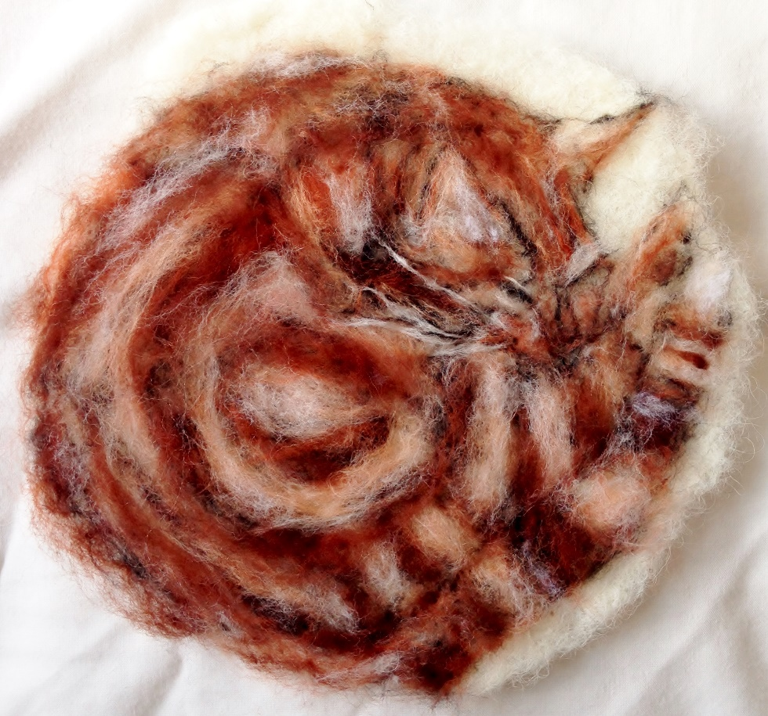
Ginger is a kitten
Better than all the rest.
He knows his name
and comes at the call.

Great, grand, glamorous Ginger
He
thinks
he’s
a
lion.
He’s very amusing.
But don’t go too close
He’ll bite or claw if he’s in a bad mood.

Ginger is warm,
his gingery coat
warming him up.

Ginger’s appearance is
very good.
He licks himself clean.
He looks like a king.
He’s a lion.

He rules whilst the waves crash into the sunburnt rocks.
He runs into walls ‘Crash’
he’s crazy.

His meow is so cute.
‘Meeeeoow’

Ginger dances around.
Ginger smells perfect.

