silence
silence
.is
a
looking
bird:the
turn
ing;edge of
life
(inquiry before snow

by e. e. cummings

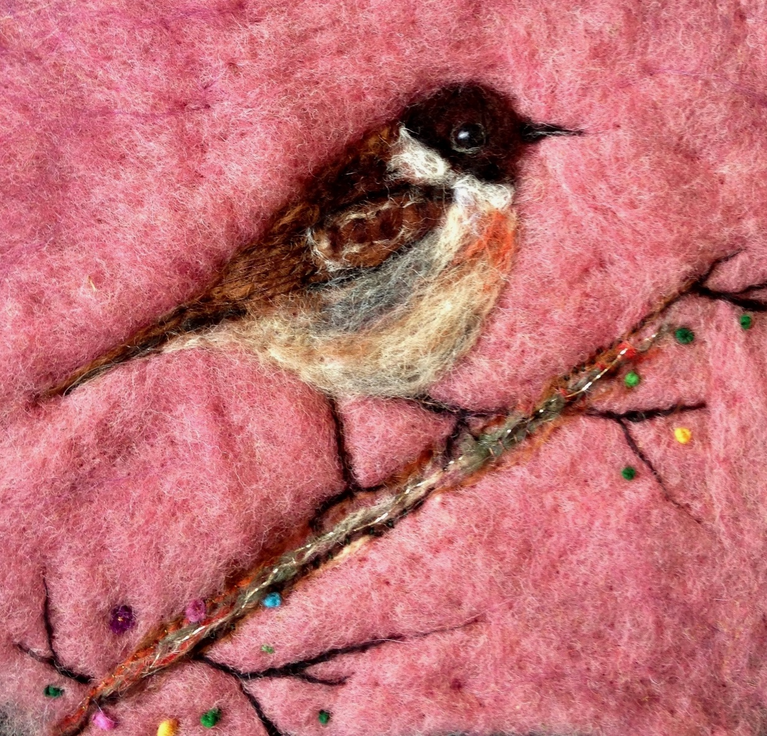
Stonechat by Rowena Scotney

